**Scroll to the top of the page with jQuery**

**Code:**

<!DOCTYPE html>

<html>

<head>

<script src ="//code.jquery.com/jquery-1.11.1.min.js"></script>

<metachar set ="utf-8">

<title>JSBin</title>

<script>

$(document).ready(function () {

$('#top').click(function () {

$("body").animate({ scrollTop: 0 });

});

});

</script>

</head>

<body>

<p>jquery</p><p>jquery</p><p>jquery</p><p>jquery</p><p>jquery</p><p>jquery</p><p>jquery</p><p>jquery</p><p>jquery</p><p>jquery</p><p>jquery</p><p>jquery</p><p>jquery</p><p>jquery</p><p>jquery</p><p>jquery</p><p>jquery</p><p>jquery</p><p>jquery</p><p>jquery</p><p>jquery</p><p>jquery</p><p>jquery</p><p>jquery</p><p>jquery</p><p>jquery</p><p>jquery</p><p>jquery</p><p>jquery</p><p>jquery</p><p>jquery</p><p>jquery</p>

<a href ='#top'>GoTop</a>

</body>

</html>

**Output:**

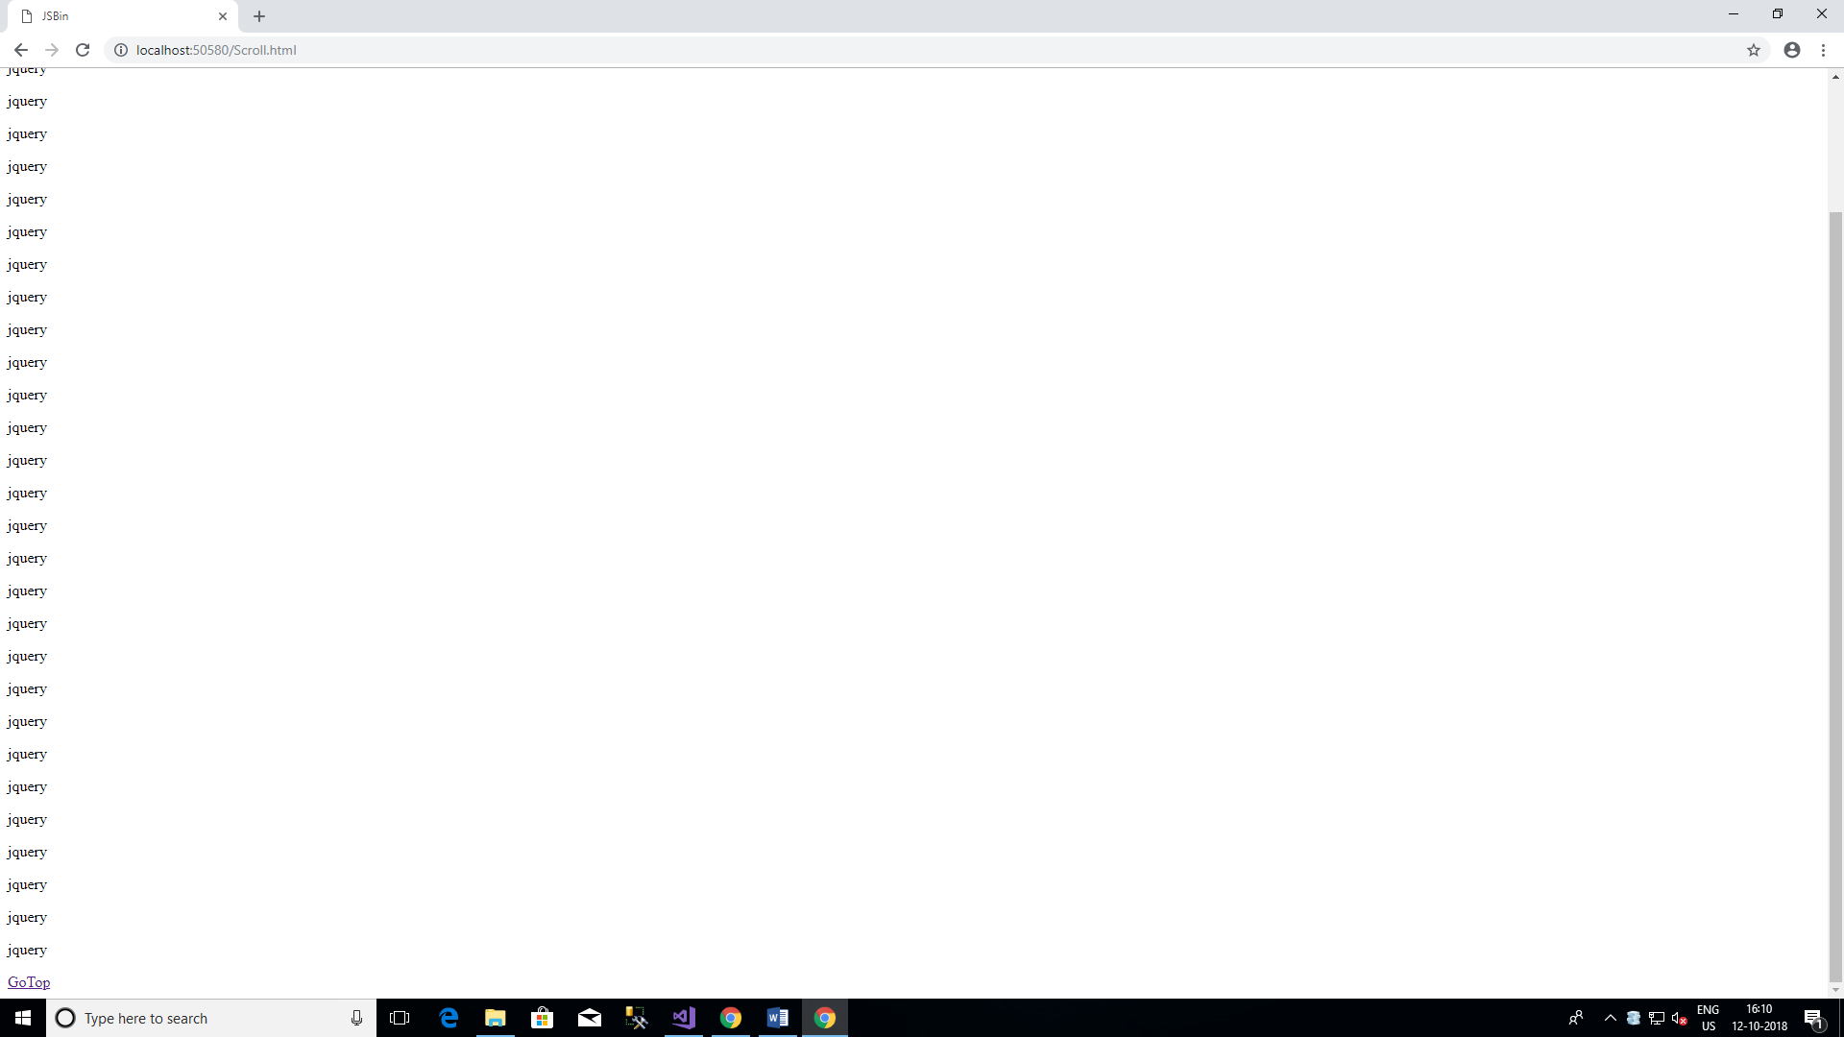

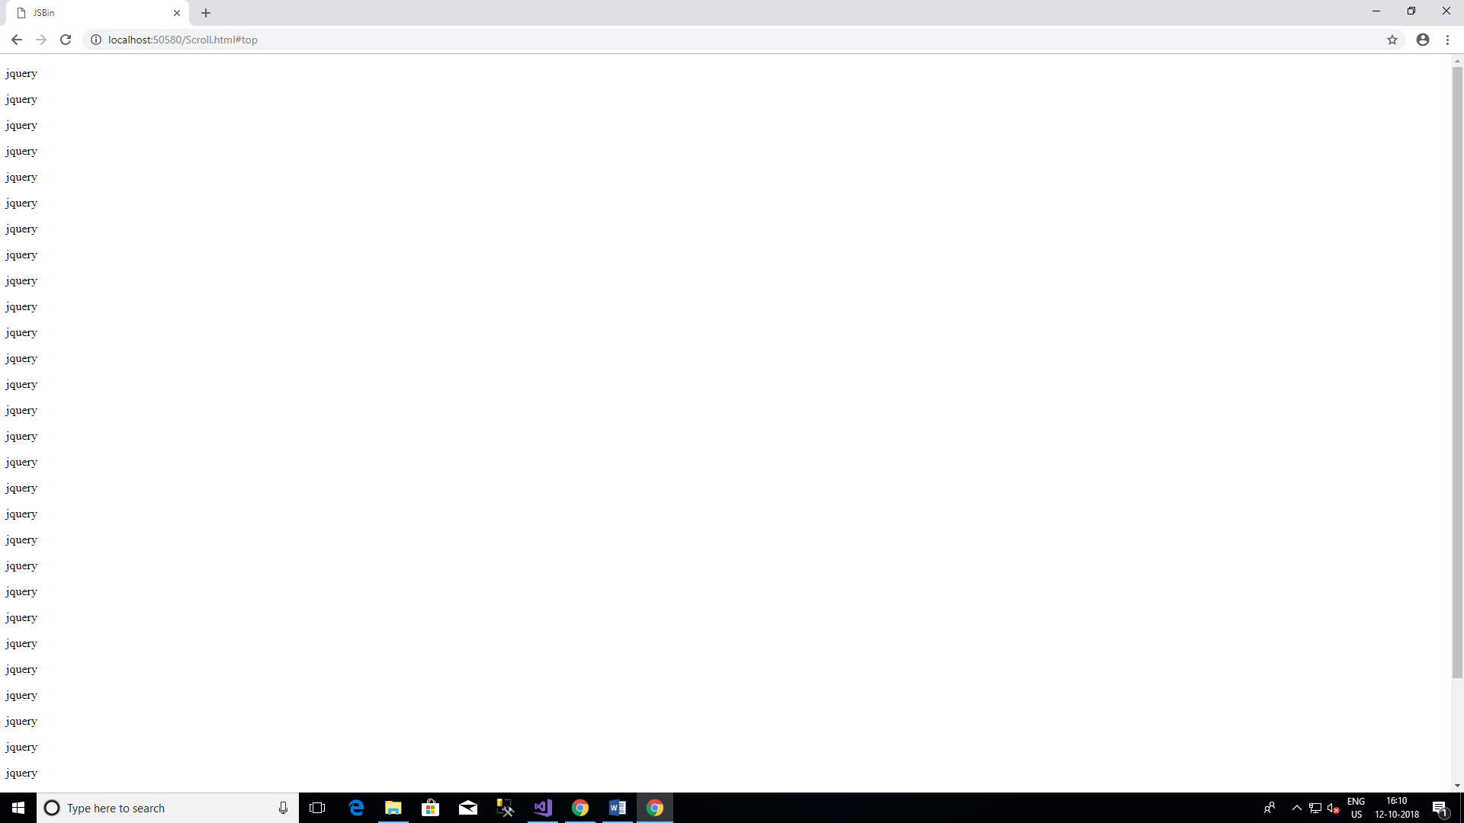

**How to detect a textbox's content has changed using jQuery?**

**Code:**

<!DOCTYPE html>

<html>

<head>

<script src ="https://code.jquery.com/jquery-git.js"></script>

<metachar set ="utf-8">

<meta name ="viewport" content="width=device-width">

<title>How to detect a textbox's content has changed using jQuery</title>

<script>

$(document).ready(function () {

$("#name1").on('input', function () {

alert("text box 1 content changed.");

});

$("#name2").on('input', function () {

alert("text box 2 content changed.");

});

});

</script>

</head>

<body>

<form action ="demo_form.asp">

Firstname:<input type ="text" id="name1" name="fname"><br>

Lastname:<input type ="text" id="name2" name="lname"><br>

<input type ="submit" value="Submit">

</form>

</body>

</html>

**Output:**

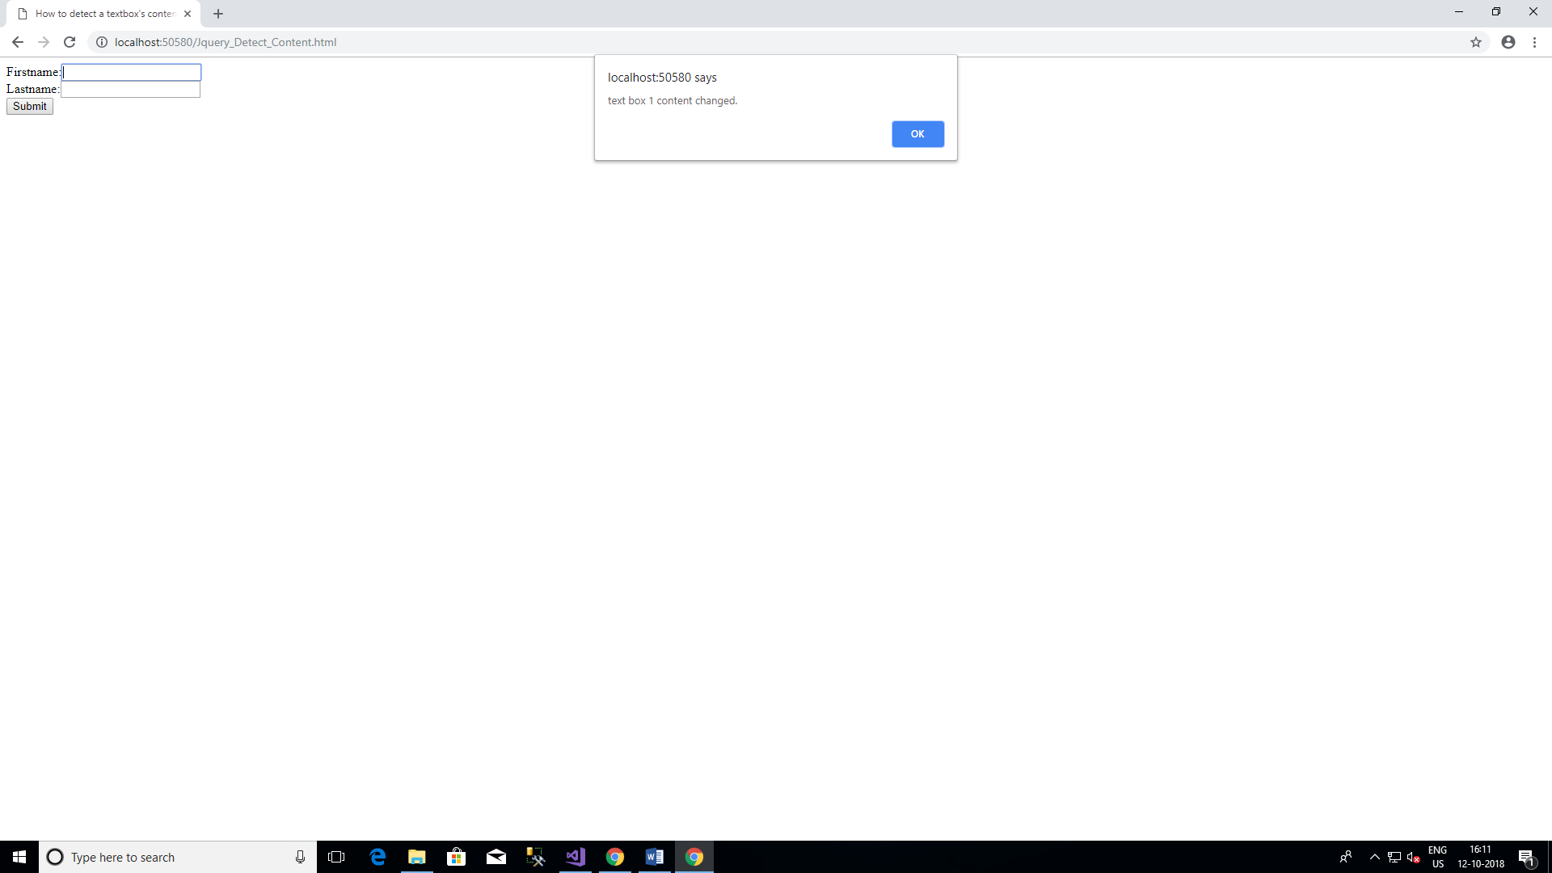

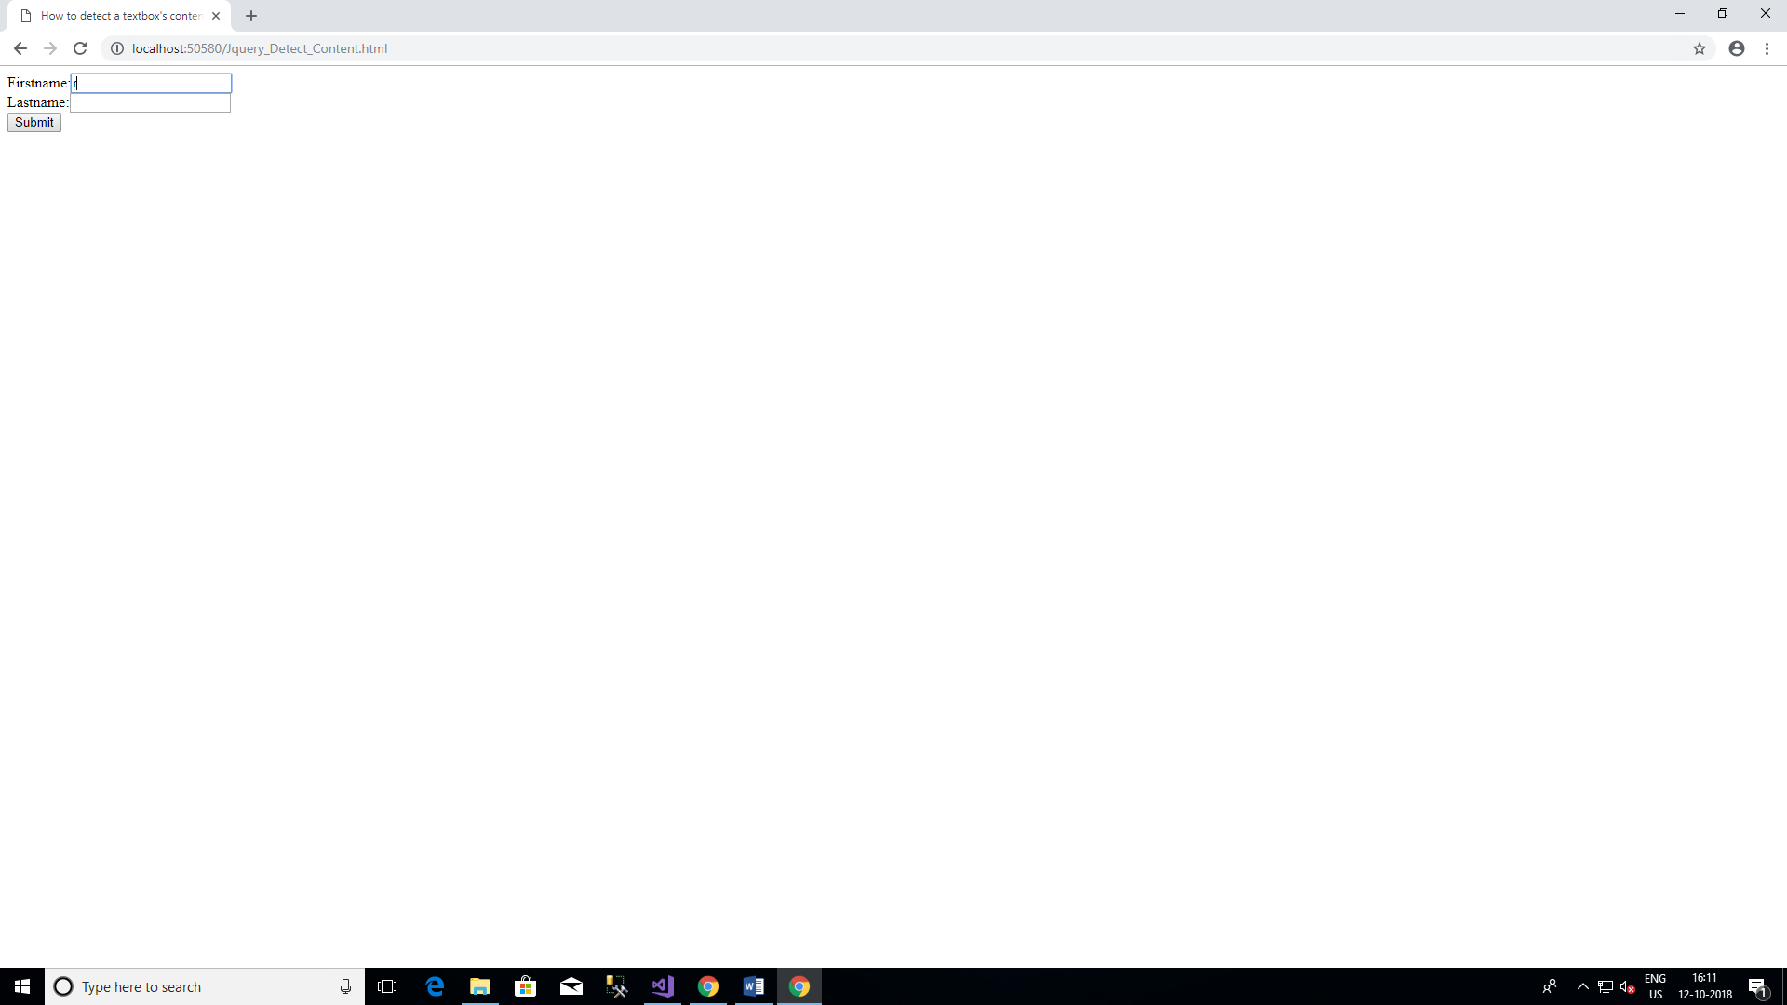

**Change button text using jQuery.**

**Code:**

<!DOCTYPE html>

<html>

<head>

<script src ="https://code.jquery.com/jquery-git.js"></script>

<meta charset="utf-8" />

<title>Change button text using jQuery.</title>

<script>

$(document).ready(function () {

$('#button1').click(function () {

$('#button1').prop('value', 'Submit');

});

});

</script>

</head>

<body>

<input type ='button' value='Cancel' id='button1'>

</body>

</html>

**Output:**





**Add 3 new options to a drop-down list using jQuery.**

**Code:**

<!DOCTYPE html>

<html>

<head>

<script src="https://code.jquery.com/jquery-git.js"></script>

<meta charset="utf-8" />

<title>Add options to a drop-down list using jQuery.</title>

<script>

$(document).ready(function () {

var otheroptions = {

val1: 'Pink',

val2: 'Blue'

};

$.each(otheroptions, function (val, text) {

$('#myColors').append($('<option></option>').val(val).html(text));

});

});

</script>

</head>

<body>

<p>List of Colors:</p>

<select id="myColors">

<option value="Red">Red</option>

<option value="Green">Green</option>

<option value="White">White</option>

<option value="Black">Black</option>

</select>

</body>

</html>

**Output:**

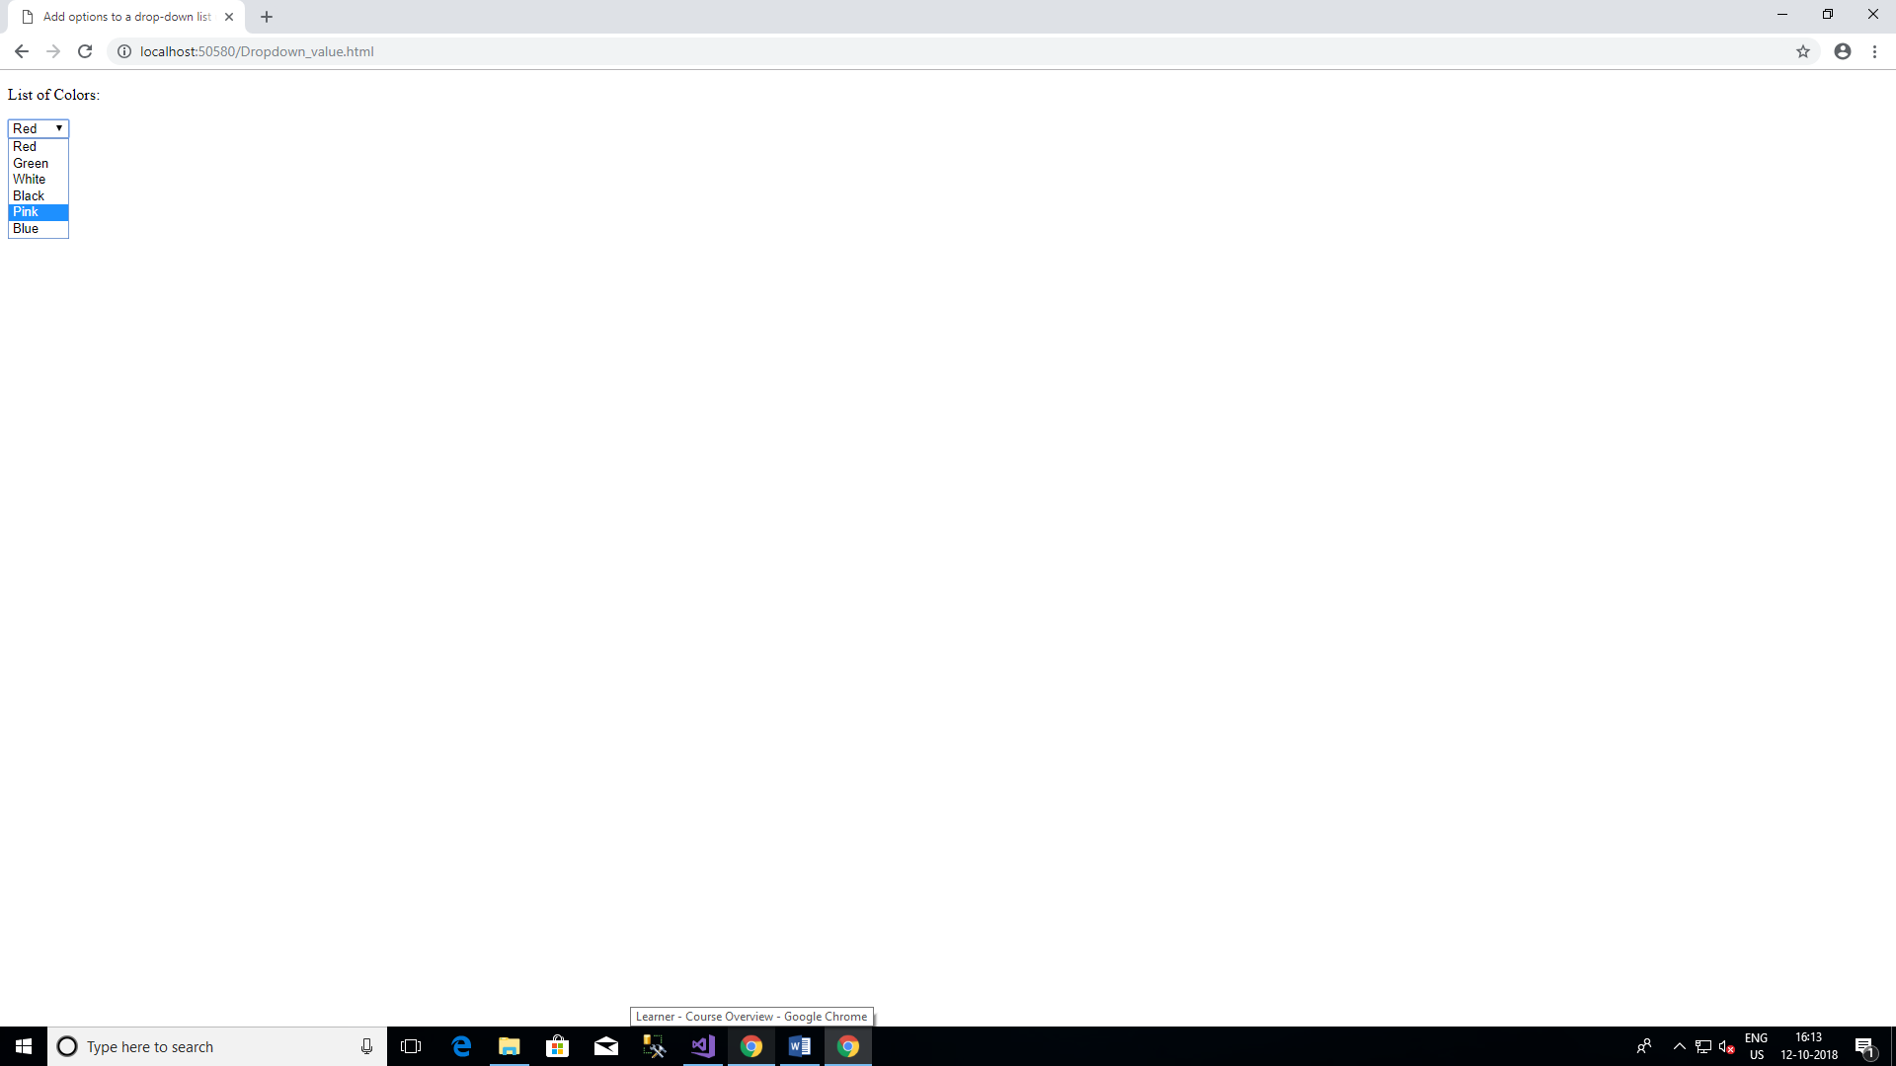

**Set background-image using jQuery CSS property.**

**Code:**

<!DOCTYPE html>

<html>

<head>

<script src="https://code.jquery.com/jquery-git.js"></script>

<meta charset="utf-8" />

<meta name ="viewport" content="width=device-width">

<title>Set background-image using jQuery CSS property.</title>

<script>

$(document).ready(function () {

$('body').css('background-image','url("image.jpg")');

});

</script>

</head>

<body>

</body>

</html>

**Output:**

